Assessment: Assignment 1

Student Name: Arbutha Durairaj

Lab Professor Name: Prof. Dave Houtman

Lab Section Number: 333

Due Date: June 7,2024

Understand the problem

The volume of donut or torus is calculated as Volume= π × r2 × 2 × π × R.

Where r is the inner radius of Donut, R is outer radius of Donut.

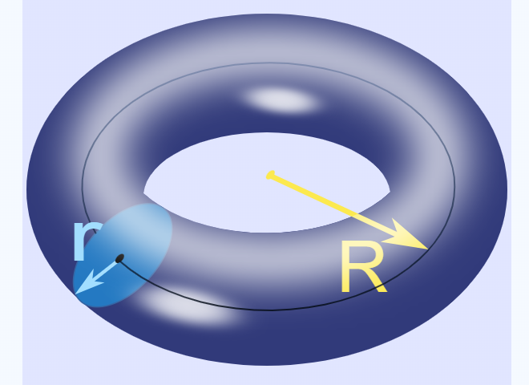

Image from references/sources cited [3]

The area inside the Donut is π × r2, the circumference of the donut is 2 × π × R.

Therefore, Volume of donut is 2 × π2 × R × r2. Also in other term, Volume of unfolded torus is similar to Volume of cylinder.

Volume of an average Tim Hortons donut:

Assuming its outer radius(R)=3 cm and inner radius(r)=1 cm

Volume of donut=2 × π2 × R × r2= 2× (3.14159) 2×3 × (1)2 =59.22 cubic centimeter.

Volume of an average tube at a water park:

Assuming its outer radius(R)=30cm and inner radius(r)=7 cm

Volume of donut=2 × π2 × R × r2= 2× (3.14159) 2×30 × (7)2 =29016.64 cubic centimeter.

Volume of an average onion ring:

Assuming its outer radius(R)=2.5 cm and inner radius(r)=0.5 cm

Volume of donut=2 × π2 × R × r2= 2× (3.14159) 2×2.5 × (0.5)2 =12.34cubic centimeter.

Formula from references/ Sources cited [2][3]

UML Class Diagram(s)

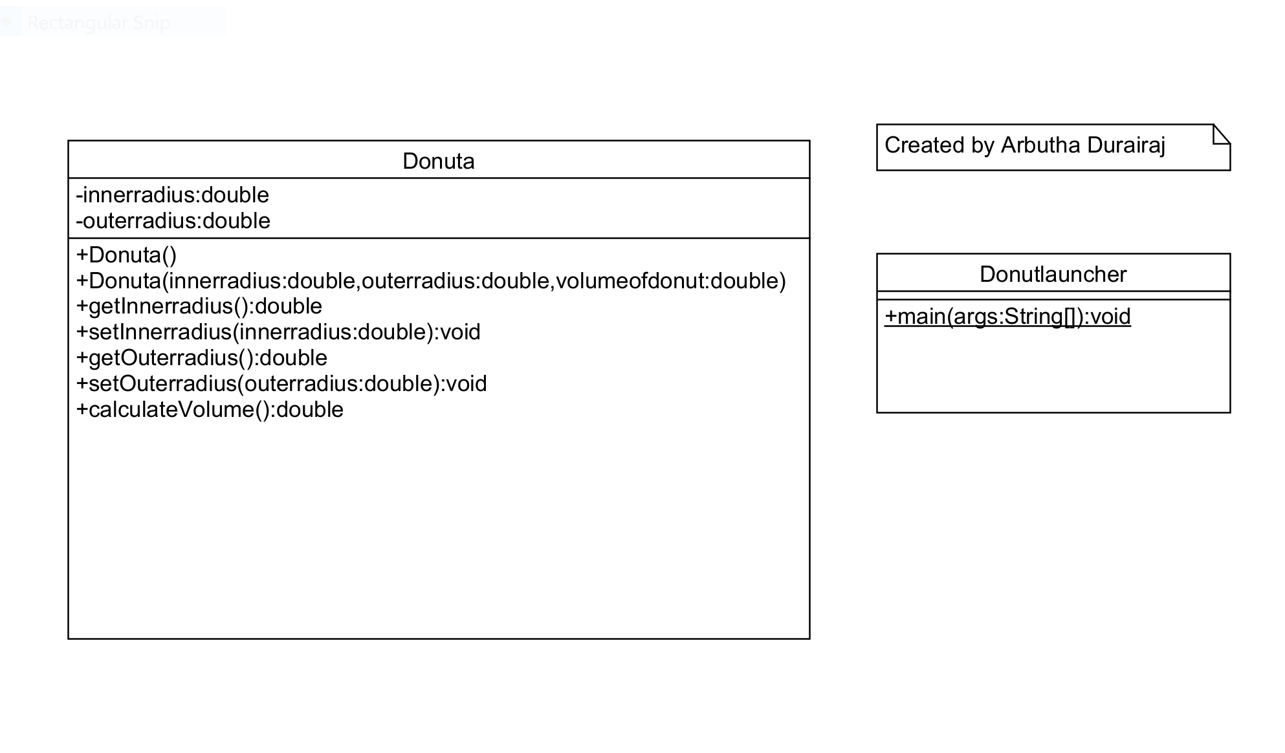

Pseudocode

Start

Declarations

num innerradius

num outerradius

num volumeofDonut

output”Enter the innerradius of donut: ”

input innerradius

output”Enter the outerradius of donut: ”

input outerradius

Donuta donut= new Donuta (innerradius, outerradius, volumeofdonut)

calculateVolume()

output”Volume is: %.2f”, volumeofdonut

Stop

calculateVolume()

volumeofdonut=2*pi2*(innerradius)2 *outerradius

return volumeofdonut

Flowchart(s)

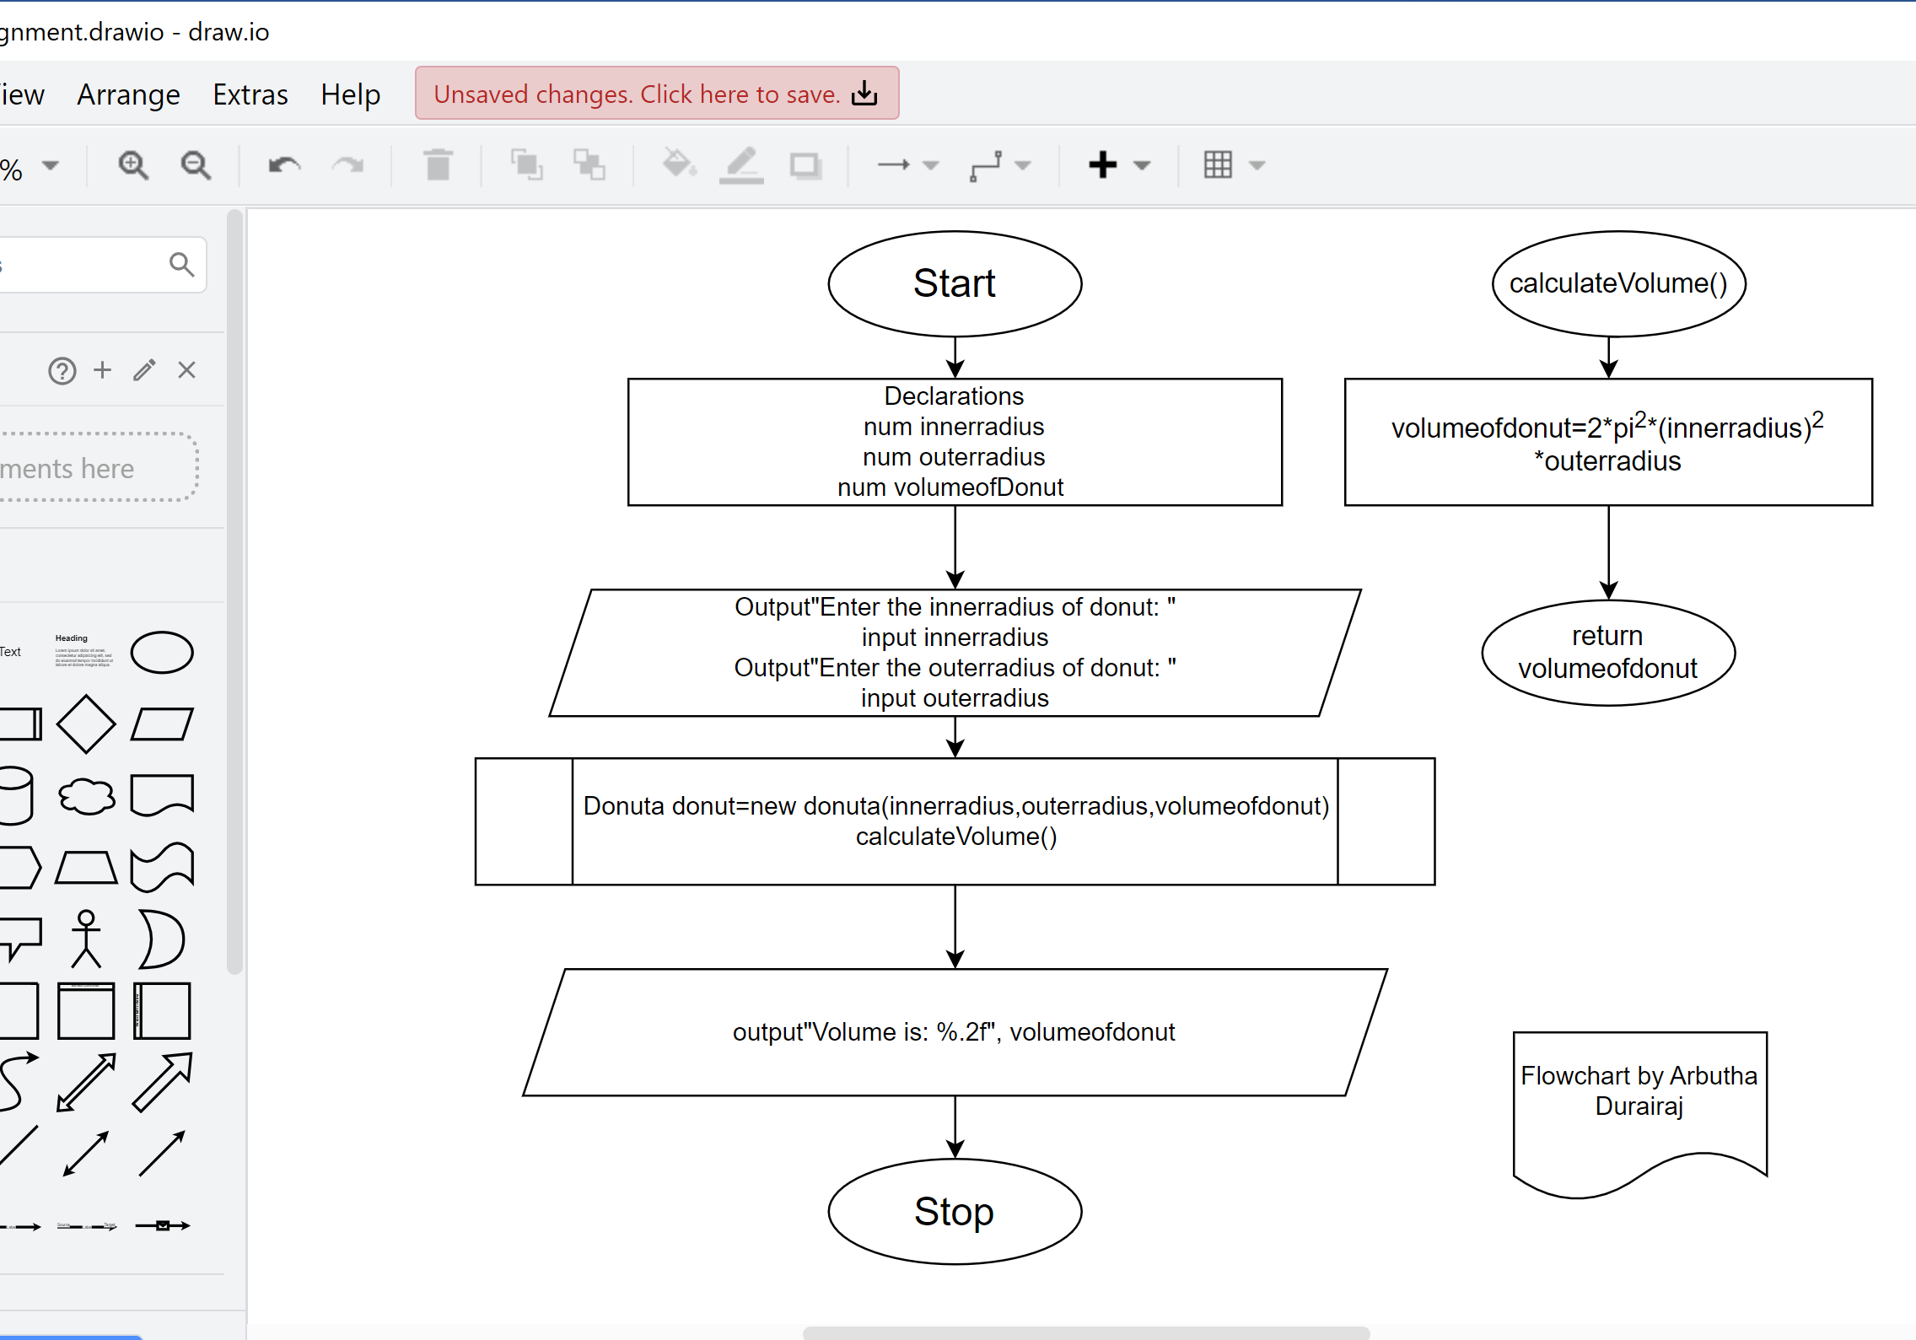

Testing Algorithm

|  |  |  |
| --- | --- | --- |
| Input | Expected Output | Description |
| 7  30 | Enter the innerradius of donut:  7  Enter the outerradius of donut:  30  Volume is: 29016.64 | Enter two inputs innerradius and outerradius as positive values. Output Volume results in decimal or float value |
| 0  10 | Enter the innerradius of donut:  0  Enter the outerradius of donut:  10  Volume is:0.00 | Enter input innerradius as zero and outerradius as positive value. Output Volume results in zero. |
| -3  -5 | Enter the innerradius of donut:  -3  Enter the outerradius of donut:  -5  Volume is: -888.26 | Enter two inputs innerradius and outerradius as negative values. Output Volume results in negative value. |
| 4  b | Enter the innerradius of donut:  4  Enter the outerradius of donut:  b  Exception error | Enter input innerradius as 4 and outerradius as string b. Exception error is excepted |
| -c | Enter the innerradius of donut:  -c  Exception error | Enter input innerradius as -c. Exception error is excepted. |
| = | Enter the innerradius of donut:  =  Exception error | Enter input innerradius as =. Exception error is excepted. |

Testing Program

|  |  |  |  |
| --- | --- | --- | --- |
| Input | Expected Output | Actual Output | Description |
| 1  3 | Enter the innerradius of donut:  1  Enter the outerradius of donut:  3  Volume is: 59.22  Program by:Arbutha Durairaj | Enter the innerradius of donut:  1  Enter the outerradius of donut:  3  Volume is: 59.22  Program by:Arbutha Durairaj | Testing the program for the output calculation volume. Codes work as expected. |
| -7  30 | Enter the innerradius of donut:  -7  Enter the outerradius of donut:  30  Volume is: 29016.64  Program by:Arbutha Durairaj | Enter the innerradius of donut:  -7  Enter the outerradius of donut:  30  Volume is: 29016.64  Program by:Arbutha Durairaj | Testing the program for the input inner radius as a negative number.  The program calculates the inner radius as a positive number and shows the correct value. |
| 0.5  -2.5 | Enter the innerradius of donut:  0.5  Enter the outerradius of donut:  -2.5  Volume is: -12.34  Program by:Arbutha Durairaj | Enter the innerradius of donut:  0.5  Enter the outerradius of donut:  -2.5  Volume is: -12.34  Program by:Arbutha Durairaj | Testing the program for the input outer radius as a negative number and also checking for both the inputs as decimal or float.  The output Volume can’t be a negative number but the output result in negative number. Codes works as excepted. |
| 0  6 | Enter the innerradius of donut:  0  Enter the outerradius of donut:  6  Volume is: 0.00  Program by:Arbutha Durairaj | Enter the innerradius of donut:  0  Enter the outerradius of donut:  6  Volume is: 0.00  Program by:Arbutha Durairaj | Testing the program with zero value for one of the inputs. Excepting the results to be zero. Code works as excepted |
| 10  a | Enter the innerradius of donut:  10  Enter the outerradius of donut:  a  Error | Enter the innerradius of donut:  10  Enter the outerradius of donut:  a  Exception in thread "main" java.util.InputMismatchException  at java.base/java.util.Scanner.throwFor(Scanner.java:939)  at java.base/java.util.Scanner.next(Scanner.java:1594)  at java.base/java.util.Scanner.nextDouble(Scanner.java:2564)  at assignment1.Donutlauncher.main(Donutlauncher.java:27) | Testing the program with string value for exception error. It shows the exception error |
| && | Enter the innerradius of donut:  &&  Error | Enter the innerradius of donut:  &&  Exception in thread "main" java.util.InputMismatchException  at java.base/java.util.Scanner.throwFor(Scanner.java:939)  at java.base/java.util.Scanner.next(Scanner.java:1594)  at java.base/java.util.Scanner.nextDouble(Scanner.java:2564)  at assignment1.Donutlauncher.main(Donutlauncher.java:23) | Testing the program with AND operator. Exception error. |

Screen Shot of Program Execution

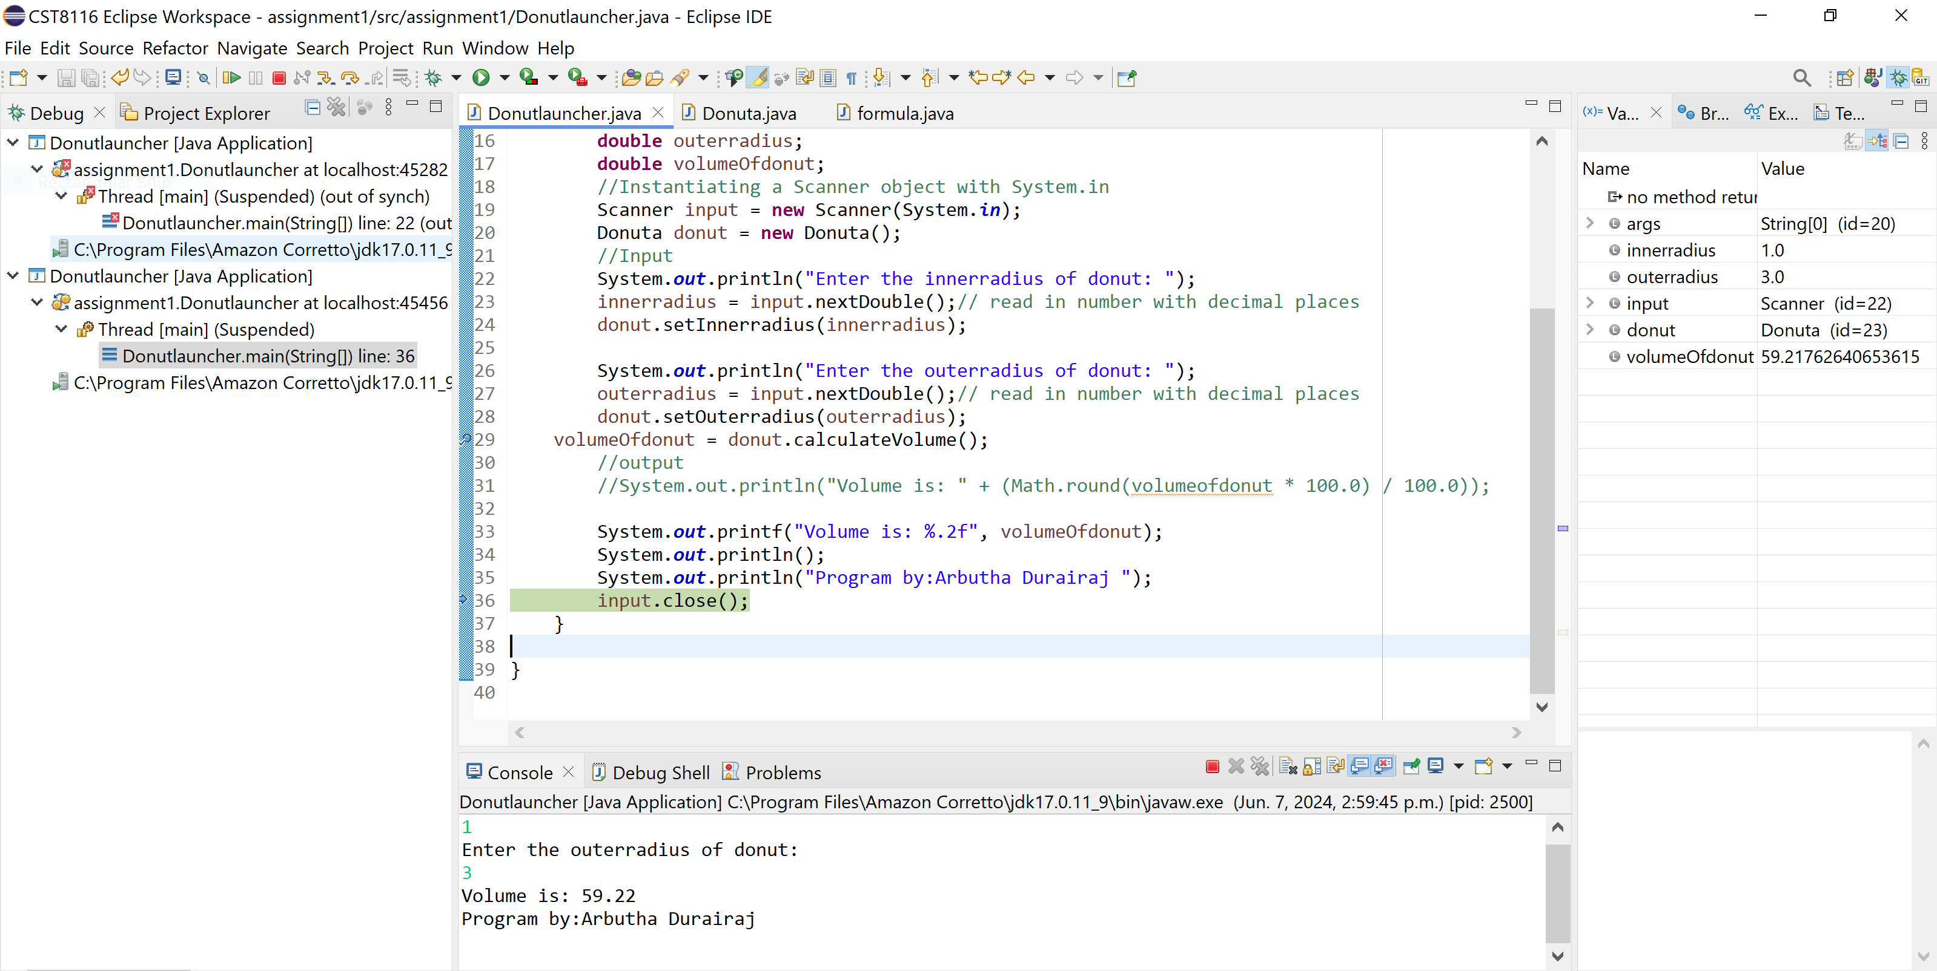

# References/Sources cited

|  |  |
| --- | --- |
| [1] | o. calculator, "https://www.omnicalculator.com/math/torus-volume," [Online]. |
| [2] | m. i. Fun, "https://www.mathsisfun.com/geometry/torus.html," [Online]. |
| [3] | Study.com, "https://study.com/academy/lesson/how-to-use-pi-constant-in-java.html," [Online]. |
| [4] | geeksforgeeks, "https://www.geeksforgeeks.org/how-to-find-the-volume-of-a-torus/," [Online]. |

# References

[1] Joyce Farrell. 2018. Programming Logic & Design Comprehensive. 9th Ed. Cengage Learning. Chapter1 pp.12 to 18, Chapter 10 pp. 428 to 437

[2] Cay Horstmann. 2019. Big Java Early Objects. 7th Ed. Wiley. Chapter 3 pp. 66 to 80